Project Report 

|  |  |
| --- | --- |
| **Product Name** | Applied Degree in Software Engineering (BDSE) |
| **Qualification Name** | Applied Degree in Software Engineering |
| **Product Name** | Programming Foundations |
| **Module Name (BDSE)** | **Programming Foundations** |

|  |  |  |  |  |
| --- | --- | --- | --- | --- |
| Learner name | | | Assessor name | |
| Abarca, Francis Roel L. | | |  | |
| **Date issued** | **Completion date** | | | **Submitted on** |
| October 26, 2022 | November 22, 2022 | | | November 22, 2022 |
|  | | | | |
| **Project title** | | Development of MCQ System | | |

### Plagiarism

Plagiarism covers both copying or paraphrasing with the source without proper understanding and citation. The source includes but is not limited to

* Books, Journal Articles, Online resources
* Others Assignment or project
* Software program
* Images

The learners must submit their work without plagiarism while producing the evidence against the assessment criteria. They must apply proper citation and Harvard referencing. Their work must go through the Turnitin software to check for the similarity index. Please consult the relevant module instructor or mentor if you need any further advice.

|  |
| --- |
| **Learner declaration** |
| I certify that the work submitted for this assignment is my own and research sources are fully acknowledged.  Student signature: Date: |
|  |

Lithan | EDU Class © 2021

## Table of Contents

Contents

Plagiarism 1

Table of Contents 3

Development of MCQ System 12

1. Introduction 12

2. Background 12

3. Task 1: Briefly describe what an algorithm is and design an algorithm to process the form inputs and outputs of the process in the project scenario. 13

4. Task 2: - Briefly describe what an algorithm is and design an algorithm to process the form inputs and outputs of the process in the project scenario. 16

5. Task 3: 17

6. Task 4: - Briefly explain how you have used object oriented features to build the application - Provide sample source code and explain how you have used object oriented features to create a particular functionality. 19

7. Task 5: - List and briefly explain the steps you will follow from writing code to execution. 19

9. Task 7: - Explain briefly how you manage the development process. 22

10. Task 8: - Explain briefly how using an IDE is better than not using an IDE.23

11. Task 9: - Explain briefly the steps involved in debugging and how does it help to develop more secure and robust applications. 23

12. Task 10: - List Coding standards you have using in the development of the application and explain 5 of them briefly with its importance. 24

### Development of MCQ System

# Introduction

#### In this project, I was tasked to design, create and test a Java-based MCQ System. This project allows me to make use of my Java skills in the form of:

#### The ability to create CLI-based apps with the knowledge of Java’s Core.

#### Create basic algorithms for a simple MCQ system that can read data from external files.

#### Implementing the application on Jetbrains’s IntelliJ IDEA IDE or DrJava.

#### Explain my knowledge of the use of the 3 Java Programming paradigms.

#### Show the debugging process and explain how it is a must for developing more robust and reliable applications.

#### Create documentation for the project itself.

# Background

#### Scenario

#### Currently, I am a student doing an internship at a company which is known to be a significant player in the education market. As part of their development, they are expanding their units to include the Information Technology subjects. I am currently a part of a team who’s producing software development to assess the subject knowledge.

#### This company has to create the MCQ system that matches the qualities shown below:

#### The system must handle multiple sets of Questionnaires. Like for example, Java Basics, C++ Basics, HTML Basics, etc.

#### After a user selects a set, the system automatically displays the questions from the selected set.

#### Let the users answer and the system calculate their scores based on their outputs. For example, the score should be at 90% when the user answers 9 questions correctly out of 10.

#### Since I am now a part of the research and development department on the company, I am tasked to investigate new processes that could benefit the company’s needs. I was tasked to find a suitable algorithm for the program.

#### I am required to explain what an algorithm is and show its use, compare its efficiency with brute-force only ones and how it can relate to the process of development down to its implementation.

#### I am also required to explain the process of debugging the program I developed and the functions of the tools given by the IDE of choice which I used to facilitate this process. I have to also include examples of the process of debugging my program to illustrate this behavior. Once my program is functioning, I review the whole process of the code debugging and create an evaluation report on how this can be used to ensure applications that I worked on are robust and secure.

# Task 1: Briefly describe what an algorithm is and design an algorithm to process the form inputs and outputs of the process in the project scenario.

# An algorithm is a group of commands that a computer uses to perform calculations and problem-solving operations. The algorithm I have thought that processes the form inputs and outputs utilize the use of Java’s Scanner utility to grab the input from the user then that exact Scanner input gets turned into a String or any variable then grabbing that exact input data then placing it inside println in order for the input to be properly understood and registered.

# 

# Java MCQ System Pseudo Code

# Read welcome class

# Print heading print quote

# Input userName

# Input option

# File csv = new File (file-path) Read csv

# String[] lineArray = line.split(,)

# Print lineArray[1,2,3,4]

# Read userAnswer = userAns.next().toUpperCase()

# int percent = (100 * score) / totalScore

# If (percent ==100)

# If (percent >= 60)

# Else

# Scanner input3 = new Scanner(System.in)

# Java MCQ System Algorithm

# The Program starts.

# Shows a text banner with a quote.

# Asks the name of the student.

# Loads the .CSV file using Java Files.

# Displays the questions to the student.

# Asks for input that registers as answers from the student.

# Calculate the score and its percentage based from the student’s results.

# Displays the name and grades of the student.

# Prompts the student to run the program again for another student or quit the program.

# Task 2: - Briefly describe what an algorithm is and design an algorithm to process the form inputs and outputs of the process in the project scenario.

# What programming paradigms you use for this project?

# Document the architecture of the System along with Module and its Components description.

* + Procedural programming is a type of programming paradigm that uses a series of steps to execute a program through procedure calls (Bhatia 2022) while Object Oriented paradigms makes use of Objects through programming which divides your code into classes where they can be inherited by the other classes and executed by the master method (Gillis 2021) and the Event driven paradigm is a type of paradigm which the program executes when there is data being received by a specific hardware or software which then can be used to execute the program. (Kolesnikova 2022) One of the programming languages that can be used to implement each of them is Java.

# For this MCQ System, I utilized both Procedural programming and Object Oriented programming.

# Example of the Programming Language which will be used to implement each of them.

# Example of a Java class storing the splash screen banner.

# Example of the Main MCQ class

# Task 3:

# Provide the source code of implementation for the algorithm written in Task 1.

# Provide a brief note on how the algorithm is translated to equivalent code.

* Implementation of the Algorithm

Step 1. Splash Screen  
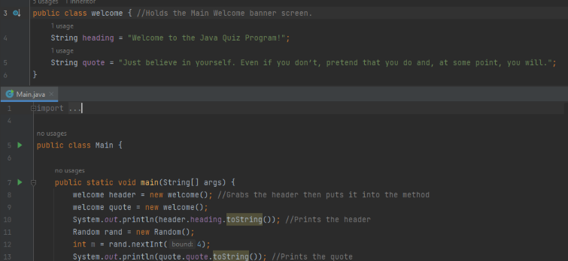

Step 2. Program asks for the user’s name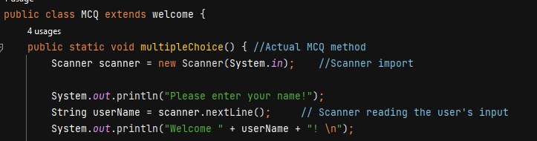

Step 3. Program loads the selection option for the user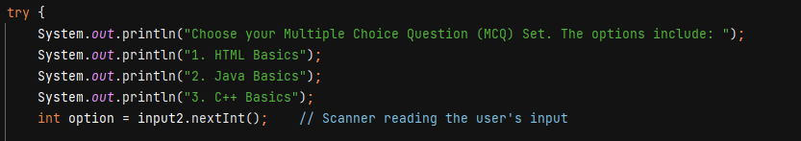

Step 4. Code verifies the input from option then loads the appropriate test 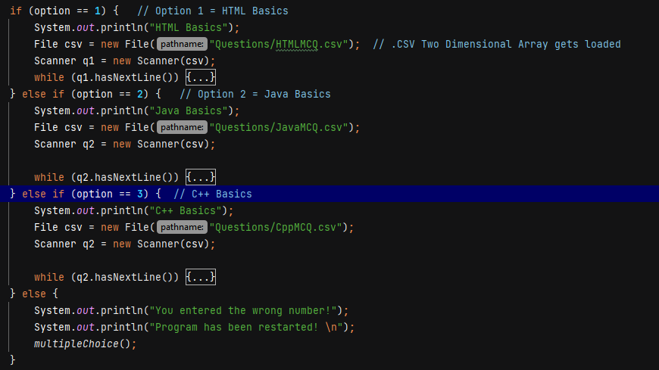

Step 5. The .CSV array gets loaded and printed onto the terminal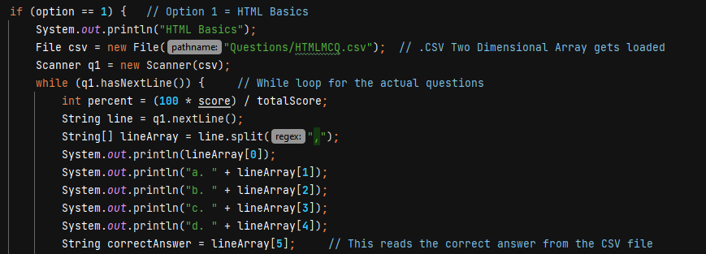

Step 6. Scanner reads the input from the user then when the program detects the correct answer stored in the array, it then reads and executes the correct answer condition which prints a nice message and adds a point to the score integer and if the answer is wrong, it then executes the else condition. 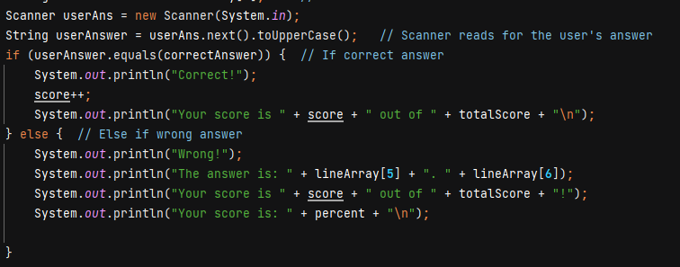

Step 7. After all the questions inside the .CSV array is done loaded and answered, the program then grabs the score integer and converts it into the wrongAns integer and the percent integer.  
 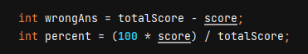

Step 8. Conditional statements here grab the output from the percent integer and compares it to either 100 or above 60 then prints the appropriate text for it. 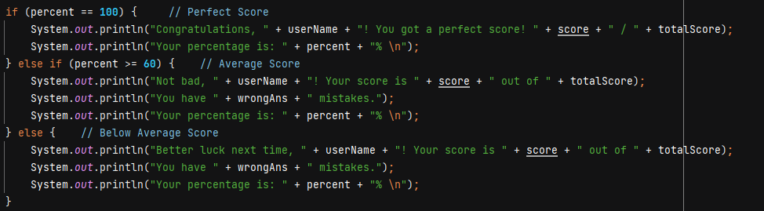

Step 9. After the game is done, a Game Over screen appears which lets you play the game again or properly quit the program. 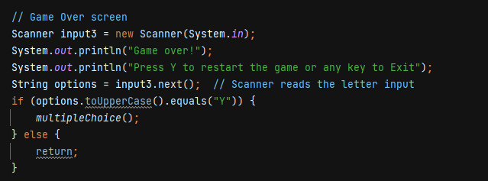

* The algorithm is translated to equivalent code by the use of logic. I did this by creating the absolute program at its minimum core first following the algorithm diagram we created before the coding process even started and going on from there.

# Task 4: - Briefly explain how you have used object oriented features to build the application - Provide sample source code and explain how you have used object oriented features to create a particular functionality. - The object-oriented parts of the code I utilized are mostly Inheritance and Encapsulation. Inheritance is used on the MCQ class which extends and makes use of the welcome class and it printing the codes onto Main as well for easy access while for Encapsulation, the whole MCQ class is hereby executed in one line inside Main which makes it handy during execution. -The welcome class utilizes this feature. - The Main class

# Task 5: - List and briefly explain the steps you will follow from writing code to execution. - The steps I followed from writing code to execution are: 1. Make a .CSV file containing the questions and answers on a database or spreadsheet software. This acts as the array for your questions. 2. Import the .CSV files onto one of the test options in the code. 3. Create a welcome class which stores the splash screen for the program. 4. Create a class called MCQ then make a multipleChoice void method. 5. Add a try-catch syntax to your code then create an integer variable that reads the input from the user. 6. Create 3 If else options for each of the .csv questions. 7. Add an else command on the end 8. Add a Scoring system algorithm onto the end of the MCQ code. 9. Add a game over menu. 10. At the end, add a catch exception. 11. Import all the classes and methods onto main.

1. **Task 6:  
   - Explain briefly 5 features which are available in IntelliJ or Eclipse which you used to build this application.**  
     
   **1. Quick Definition feature  
   -** This feature was able to help me get a better understanding as a beginner as to how Java’s classes and the connected variables are with just a hover of the cursor.  
   **2. Find Usages tool  
   -** This feature also helped me analyze the code much more easily and check whether if one of my classes were running correctly or not.

**3. Live Templates  
-** This feature allowed me to speed up my Java coding workflow by over 20 minutes compared to without having Live templates.   
**4. Tile Windows  
-** This allowed me to significantly and easily view my code on one display in real time without the need for switching to tabs which significantly helped me speed up doing my code albeit it makes my desktop a whole lot messier in the process.  
**5. Built-in Terminal  
-** This feature allowed me to run Java code without the need for SSH’ing to my server just to run test code which saves a lot of time during development.

# Task 7: - Explain briefly how you manage the development process. We managed the development process by first planning out the algorithm itself on a flowchart piece by piece then we followed the list of Coding Standards to ensure that our code meets the right standards then the coding is done right after. During the process, it was compiled with us reading the documentation multiple times to get the desired variable we need and make use of it on our code. We utilized the IDE’s Find feature and tiled windows for maximum efficiency.

# Task 8: - Explain briefly how using an IDE is better than not using an IDE. Using an IDE is light years better than not using one because its simply due to the fact that an IDE is designed to make coding super seamless by bundling all the extensions and tools that programmers use on a daily basis onto a single program and making them super easy to access as well. This saves a significant amount of time that a lot of programmers adore IDEs.

# Task 9: - Explain briefly the steps involved in debugging and how does it help to develop more secure and robust applications. Steps in debugging involves the use of IntelliJ’s breakpoints manager which in the program’s case, it’s the InputMismatchException and its being catched by the end of the line to output a proper response. Debugging helps a lot in developing more secure applications since it allows the developer to find more bugs executed by the code when a user inputs then fixing them which increases the stability of the program itself. Debugging code is not an easy process but its worth the effort nonetheless.

# Task 10: - List Coding standards you have using in the development of the application and explain 5 of them briefly with its importance. During the development of this application, here are the list of coding standards I have utilized on my code.

* 1. Code Readability  
     The code of the program utilizes a series of variables that are basic and understandable to a novice programmer which helps in code replication and understanding.
  2. Utilization of Exception Handling  
     The main codebase of MCQ utilizes Exception Handling to prevent any catastrophic errors that may damage the usability of the code and better understand the end user as to what the issue is when it does happen. The main code for the MCQ test is enclosed in a try-catch block for exception handling purposes.
  3. Adding brief comments to the code  
     The codebase of this project heavily utilizes comments that briefly explain the purpose of one of the master lines on the code which can also help in replication together with Code Readability.
  4. Separating the code’s methods and classes  
     Specifically, this codebase utilizes separate methods and classes for the ease of modification and management during maintenance and debugging.
  5. The use of Standard Libraries in Java

This program utilizes the standard Java Library which makes the program super easy to replicate and run since pretty much the program’s library is available in every JRE that everyone uses.